Using the DBGI Portal
A step-by-step guide for partners and DBGI staff
All companies, people, and prices in this guide are examples. The sample end-user is the City of Lucena Mayor's Office.
How to use this guide. Each part says who it is for. Partners can skip the parts marked DBGI.

What is in this guide
- Part 1: Getting started
- Part 2: Register a deal
- Part 3: Follow your deal
- Part 4: Review a deal
- Part 5: Fix a returned deal
- Part 6: Confirm the deal
- Part 7: Approve the price
- Part 8: See the result
- Part 9: Change a deal
- Part 10: Withdraw a deal
- Part 11: Report the result
- Part 12: Time limits
- Part 13: Other DBGI tasks
- Part 14: Repeat orders
- Part 15: Quick help

Start here

What is this portal for?
Use it to tell DBGI about a government project before the bid.
Who | What they do in the portal
Partner | Registers deals, follows them, asks for price renewals, reports the result
DBGI | Checks deals, confirms the project, decides prices, keeps the rankings
Each company sees only its own deals, ranks, and prices. No company can see another company's.

The journey of a deal
Every deal follows the same path. The parts of this guide follow it too.
- Partner registers the deal (Partner)
- DBGI reviews it (DBGI)
- DBGI confirms the project. The deal is Registered and gets a rank. (DBGI)
- DBGI decides the price (DBGI)
- Partner sees the price and can ask to renew it (Partner)
- Partner reports if the project was won or lost (Partner)

Our example deal
We follow one deal from start to finish.
Detail | Example
End-user (the government buyer) | City of Lucena Mayor's Office
Project | 20 laser printers for the Mayor's Office
Product | M1820W, 20 ppm monochrome laser printer
List price | 10,000.00 each
Price the partner asks for | 9,000.00 each
Competitor | Canon imageCLASS LBP246dw at 9,300.00
All prices in the portal include VAT.

Part 1: Getting started

Sign in (Everyone)
- Open the portal link.
- Type the username and password DBGI gave you.
- Click Sign in.
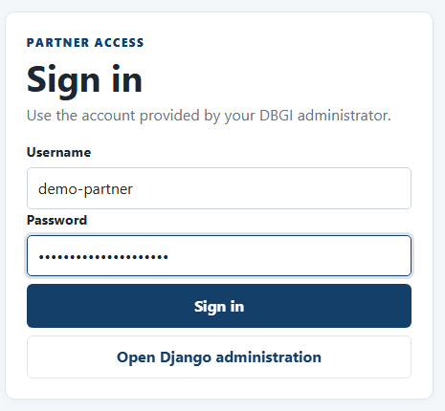
Figure 1. The sign-in page
Forgot your password? Ask your DBGI administrator. Do not share your account.

Your list of deals (Partner)
After you sign in, you see all your company's deals.
- Each row is one deal.
- Click the blue reference number to open a deal.
- Use the search box and filters to find a deal.
- Click New registration to add a deal.
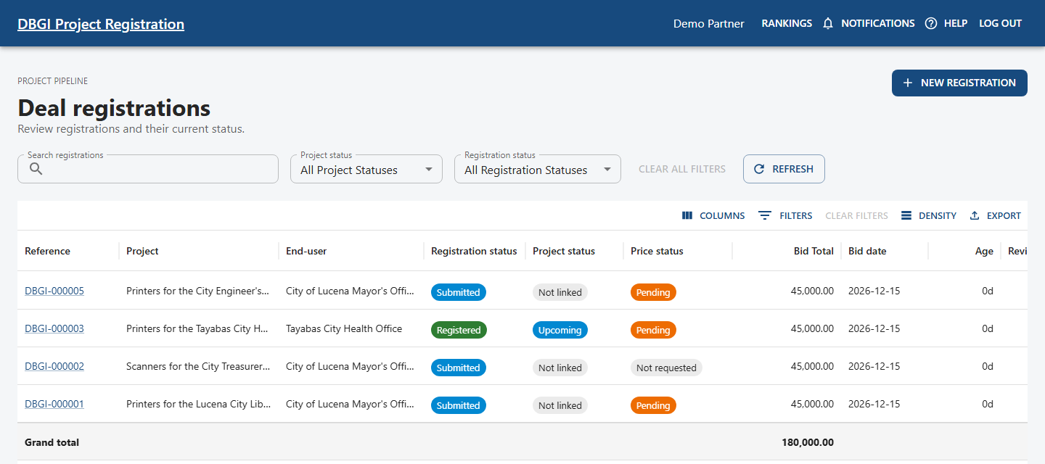
Figure 2. The deal list

Find help and messages (Everyone)
- Click Help in the top menu for short steps inside the portal.
- Click Notifications to read your messages.
- Click Rankings to see your place on a project.
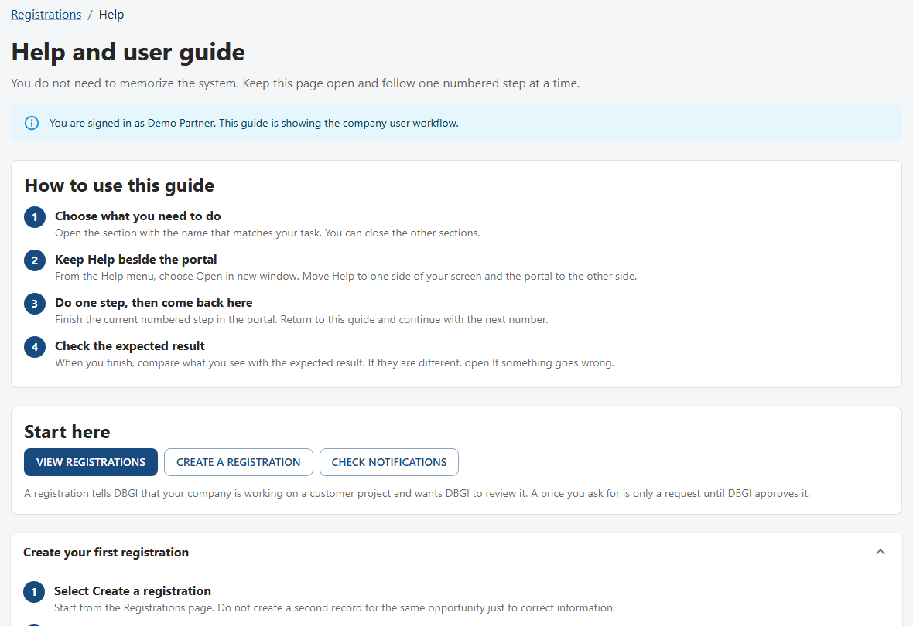
Figure 3. The Help page

Part 2: Register a deal

Step 1: Who is the buyer? (Partner)
- Click New registration.
- In End-user, type the buyer's name and choose it.
- Not in the list? Click Add missing end-user. DBGI will check it.
- Type the project title, bid date, and delivery date.
- Check your contact details. They are filled in for you.
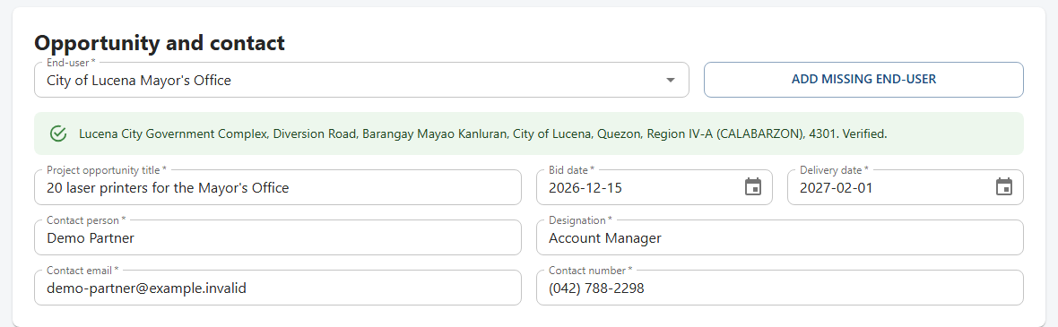
Figure 4. End-user, project, and contact details

Step 2: Who are you up against? (Partner)
- Click Add competitor.
- Type the brand and the model.
- Type the price they offered in Bid price.
- Click Save item.
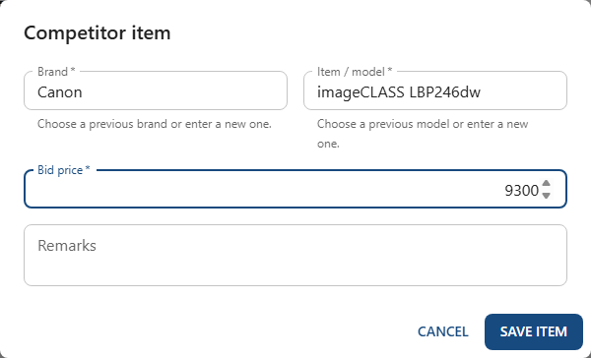
Figure 5. Adding a competitor
More than one competitor? Click Add competitor again.

Step 3: What do you want to sell? (Partner)
- Click Add product.
- Choose the product. If it is not listed, choose Not in catalog and describe it.
- Type the quantity and the price you are asking for.
- Say why you need this price in Justification.
- Click Save item.
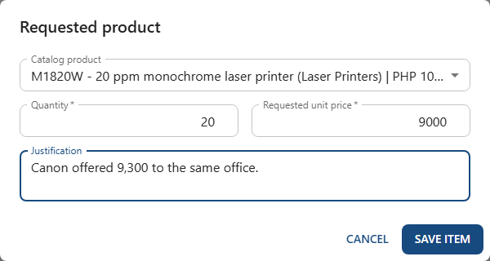
Figure 6. Adding a product
The price you type is only a request. It is not approved until DBGI says so.

Step 4: Add your proof and send (Partner)
- Describe your proof, like a request for quotation.
- Add a link or click Add files.
- Tick the box to confirm you may share it.
- Click Create registration.
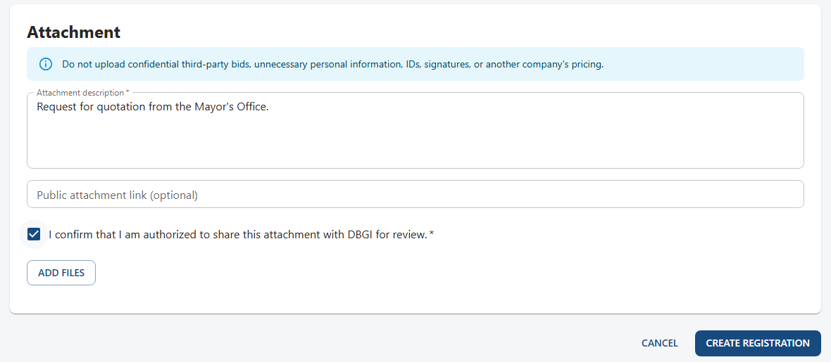
Figure 7. The attachment section and the Create registration button
Do not upload other companies' prices or bids, IDs, signatures, or private personal details.

Why you should register early (Partner)
The portal records the exact time you send your deal. This time decides your place in line for the project. Nobody can change it, and later edits do not change it.
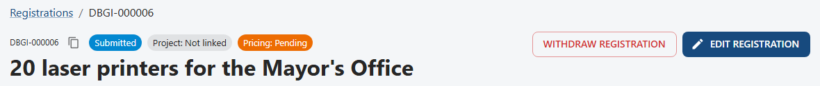
Figure 8. Your new deal, with the status Submitted
A partner that registers first gets rank 1 once DBGI confirms the deal. Rank 1 gets the best price.

Part 3: Follow your deal

Read your deal page (Partner)
- The labels at the top show the deal, the project, and the price status.
- What happens next? tells you the next step.
- Commercial approvals shows DBGI's price decision.
- Activity shows everything that happened, who did it, and when.
Figure 9. What happens next
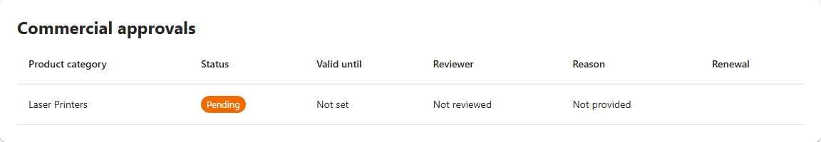
Figure 10. Commercial approvals: DBGI has not decided yet
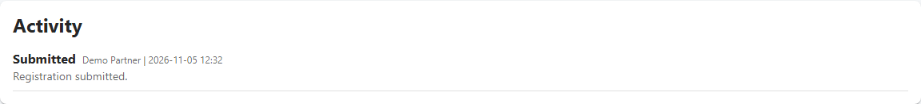
Figure 11. Activity

What each status means (Partner)
Status | What it means | What happens next
Submitted | DBGI received your deal | DBGI starts the review
Under review | DBGI is checking it | DBGI decides
Returned for changes | DBGI needs you to fix something | You edit and save
Resubmitted | You sent your fixes | DBGI checks again
Registered | DBGI confirmed the project. You have a rank. | Price decision
Review required after edit | You changed a Registered deal | DBGI checks again. Your rank stays.
Rejected | DBGI said no. The reason is in Activity. | This is final
Withdrawn | You took the deal back | This is final

Your messages (Partner)
- Everyone in your company sees portal messages about your deals.
- The person who registered the deal also gets an email.
- Click View registration to open the deal.
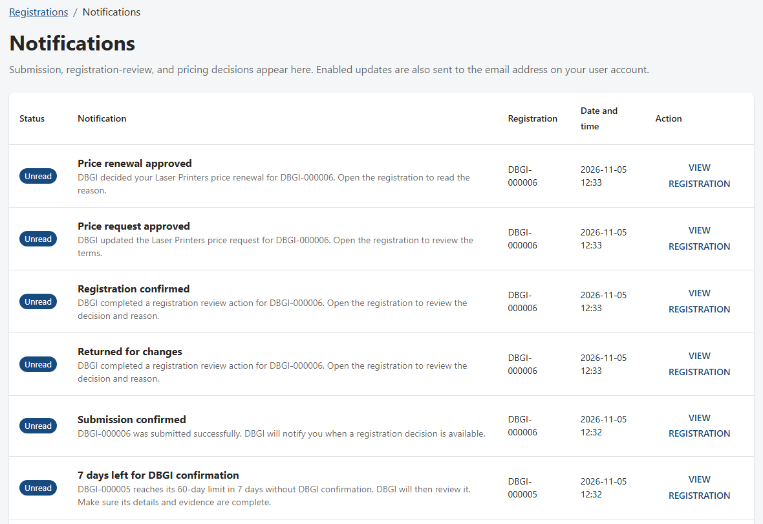
Figure 12. The Notifications page
The portal message is the official record. The email is only a copy.

Part 4: Review a deal

See what needs your action (DBGI)
- Sign in and click Administration in the top menu.
- The dashboard lists deals to review and prices to decide.
- It also shows end-users to check, failed emails, and prices about to end.
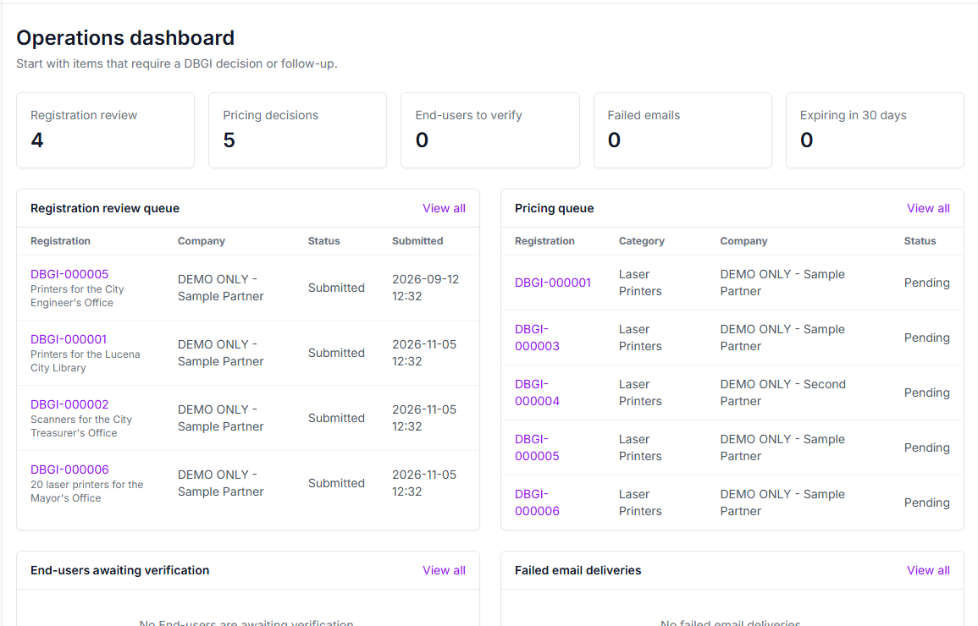
Figure 13. The operations dashboard

Start the review (DBGI)
- Open the deal.
- Read the System recommendation. It is only a hint. You decide.
- Check the details and the attachment.
- Type why you are starting in Review reason.
- Click Start review.
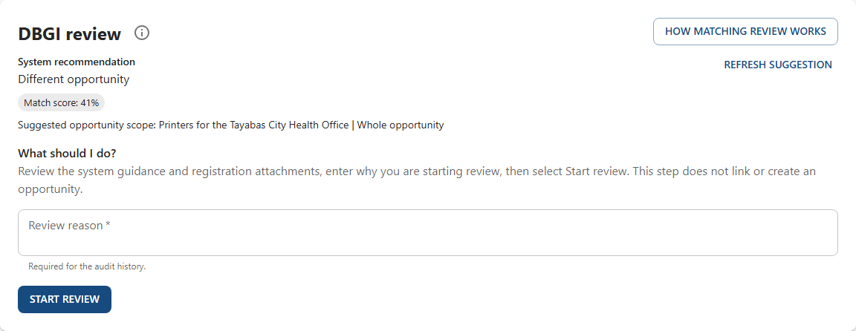
Figure 14. The review box before the review starts

Choose one of four decisions (DBGI)
Choice | Use it when
Link to an existing opportunity | The project is already in the portal
Create a new whole opportunity | This is the first deal for this project
Request changes | The partner must fix or add something
Reject registration | The deal cannot go on. Explain why.
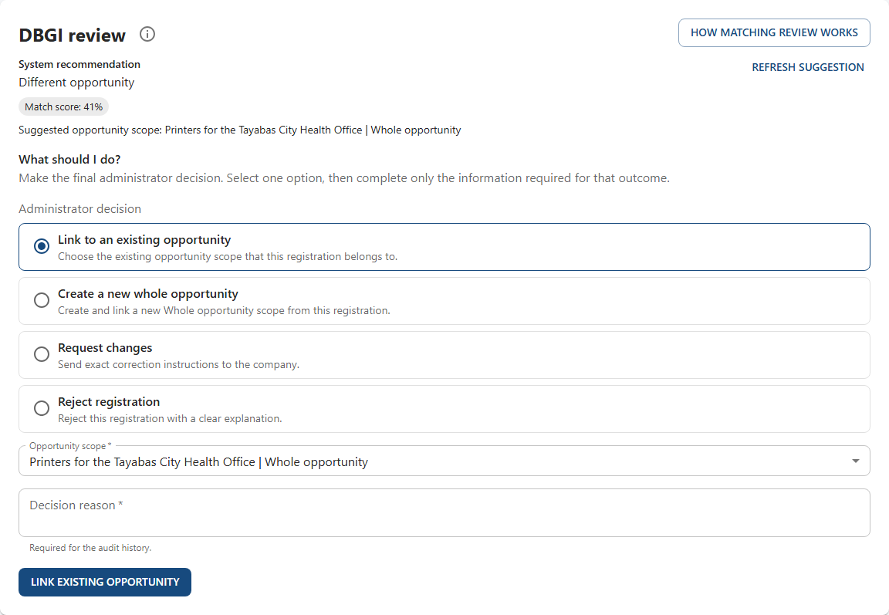
Figure 15. The four decisions
The partner can read your change instructions or rejection reason in Activity. Other reasons stay inside DBGI.

Part 5: Fix a returned deal

DBGI asks for changes (DBGI)
- Choose Request changes.
- Say exactly what to fix in Instructions for company.
- Click Request changes.
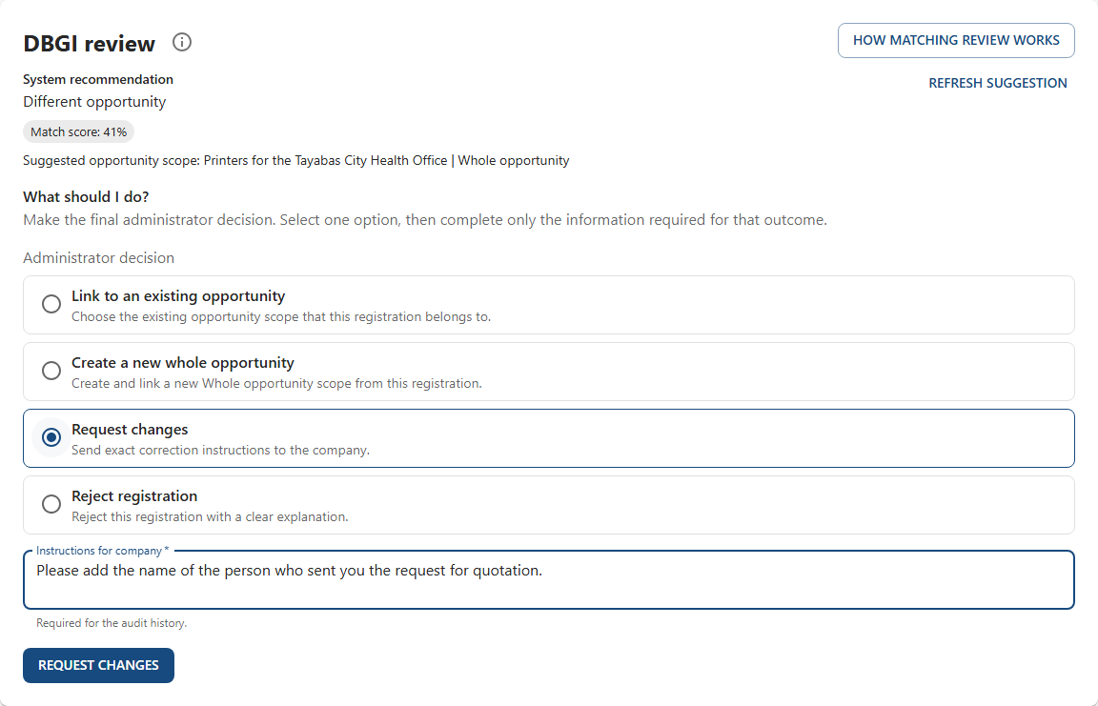
Figure 16. Writing the instructions

The partner reads what to fix (Partner)
- You get a message. The status is now Returned for changes.
- Open the deal.
- Read DBGI's instructions under Activity.
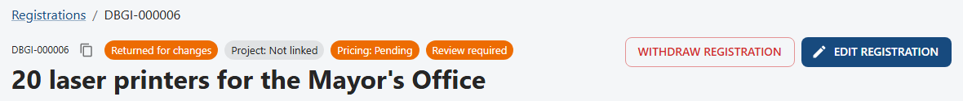
Figure 17. The deal is returned
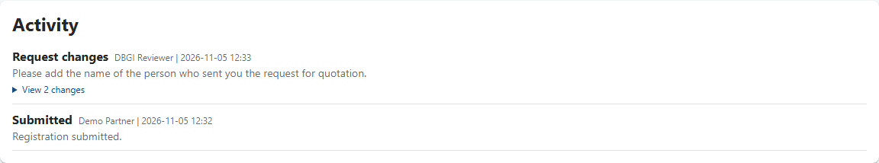
Figure 18. DBGI's instructions in Activity

The partner fixes it and saves (Partner)
- Click Edit registration.
- Make the change.
- Click Save changes.
- The status becomes Resubmitted and DBGI checks it again.
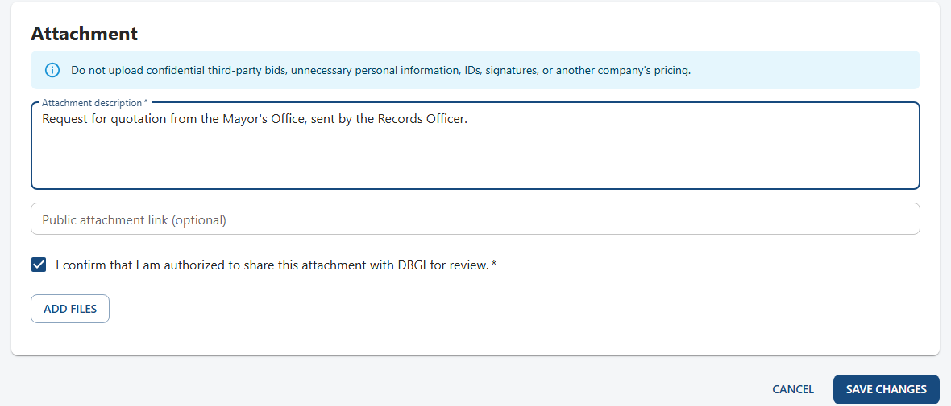
Figure 19. Editing the attachment description
Your place in line does not change when you fix a returned deal.

Part 6: Confirm the deal

DBGI confirms the deal (DBGI)
- Start the review again.
- Choose Create a new whole opportunity, or link to an existing one.
- Type your reason in Decision reason.
- Click the button at the bottom of the box.
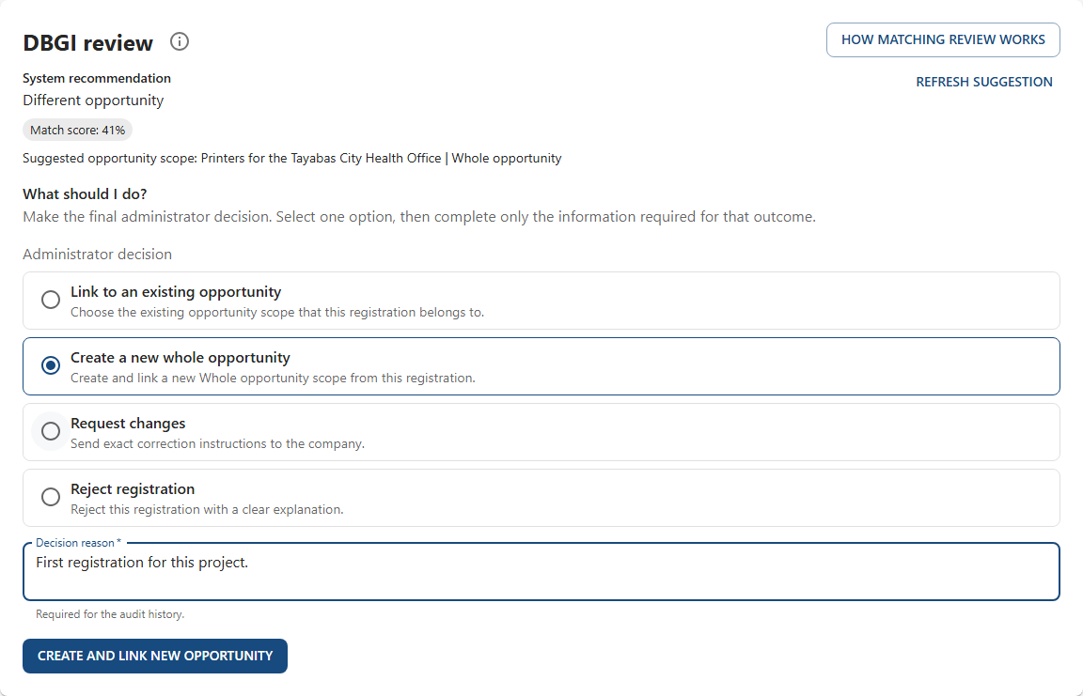
Figure 20. Creating a new project for this deal

The deal is now Registered (Everyone)
The deal now belongs to a project, and it has a rank. The price is decided separately.
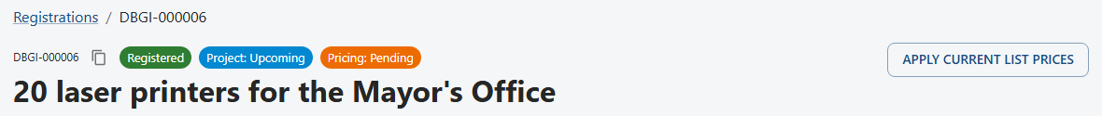
Figure 21. The Registered label and the project label
Sometimes the portal does this by itself. It happens only when the end-user's name and address and all the products exactly match one project. The partner gets a message.

Part 7: Approve the price

Open the price decision (DBGI)
- Click Administration.
- Click Price approvals in the left menu.
- Search for the deal and open it.
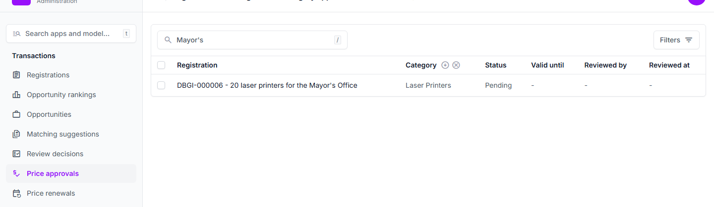
Figure 22. The Price approvals list

Approve the price (DBGI)
Rank 1 gets the best price. Everyone after rank 1 gets the same price. The form shows the rank and other prices.
- Set Status to Approved.
- Type your reason in Rationale. The partner can read it.
- Valid until: choose the end date. If you leave it blank, the price lasts 90 days.
- Under Registration item approvals, click Add another.
- Choose the product and type the approved price.
- Click Save. A warning means the price breaks the rule. It still saves, so you can make an exception.
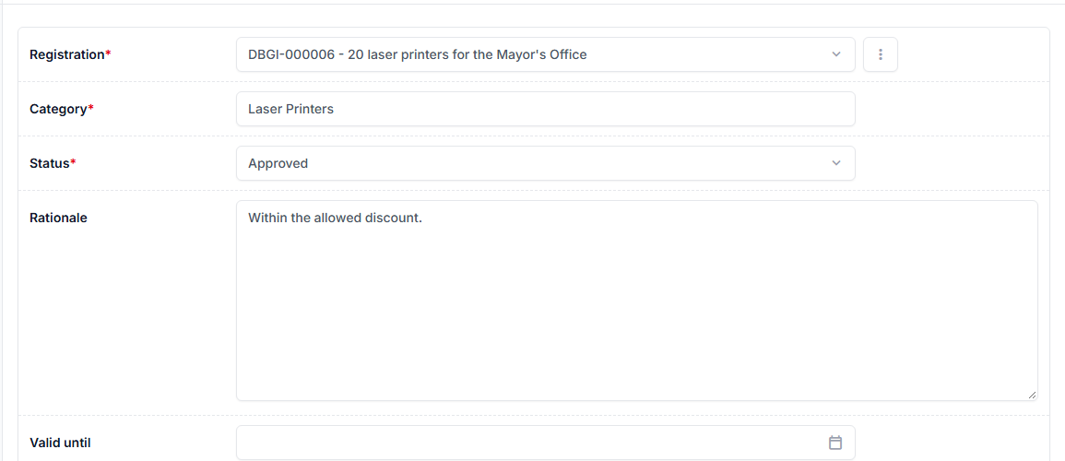
Figure 23. The top of the form: status, reason, and end date
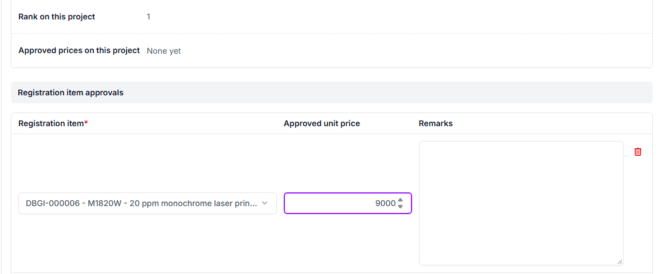
Figure 24. The bottom of the form: the approved price for each product
Do not skip the approved price. If you do, the partner sees Pending instead of the price.

Part 8: See the result

The partner sees the price (Partner)
- You get a message.
- Commercial approvals shows the decision, the end date, and the reason.
- Requested products shows the approved price for each product.
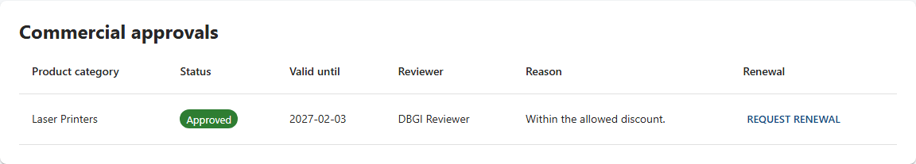
Figure 25. The approved price decision and its end date
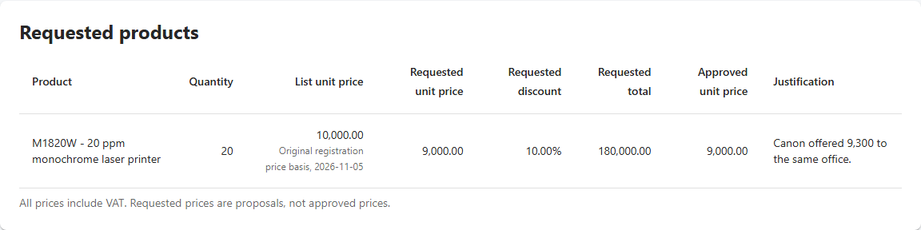
Figure 26. The approved unit price

Ask to renew a price (Partner)
You get a reminder 14 days before the price ends. If you need more time, ask for a renewal.
- Click Request renewal in Commercial approvals.
- Type your reason.
- Click Send request.
- The page shows Waiting for DBGI until DBGI answers.
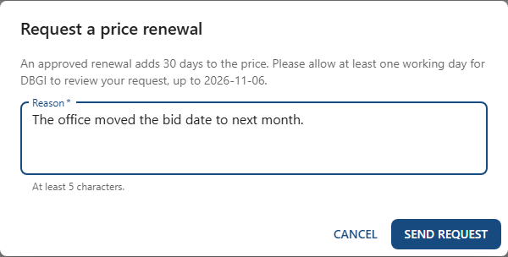
Figure 27. Asking for a renewal
You can send one request at a time. Please give DBGI at least one working day.

DBGI answers the renewal (DBGI)
- You get a message and an email.
- Open the deal. The partner's reason is in Commercial approvals.
- Click Approve or Decline, then type your reason.
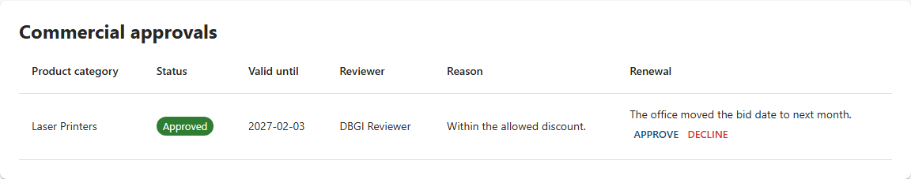
Figure 28. The renewal request on the deal page
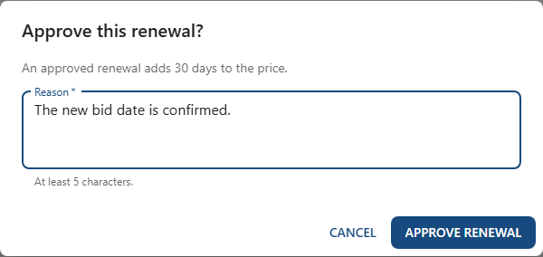
Figure 29. Approving the renewal
Approving adds 30 days to the end date. If the price has already ended, the 30 days start today. Declining keeps the same date. The partner gets a message either way.

See your rank (Partner)
- Click Rankings in the top menu.
- Rank is your place on that project. The first to register gets rank 1.
- Rank 1 gets the best price. Everyone after rank 1 gets the same price.
- You see only your own rank, not the other companies.
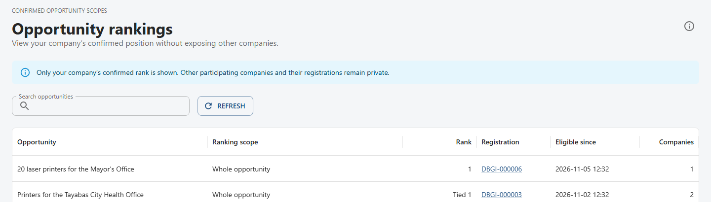
Figure 30. The Rankings page
Tied means another company registered at the very same time. DBGI will decide the order.

Part 9: Change a deal

How to change a deal (Partner)
You can edit your deal any time until you withdraw it. Some parts lock during review.
- Open the deal and click Edit registration.
- Make your change and click Save changes.
- Want today's list price? Tick the box at the top of the page. DBGI will check it.
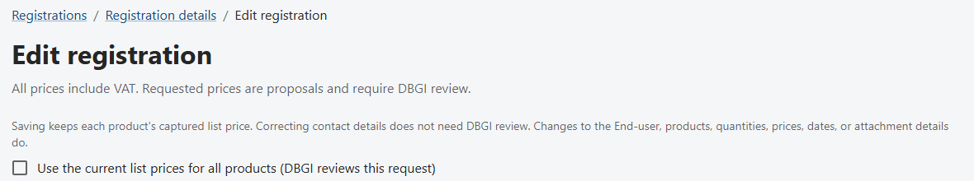
Figure 31. The top of the edit page, with the list price box
If someone else saved first, the portal asks you to refresh. It will not overwrite their work.

Which changes does DBGI check? (Partner)
DBGI does not need to check | DBGI must check
Contact person, designation, email, and number | End-user, project title, bid date, delivery date
Competitor remarks and product justifications | Competitor brand, model, or bid price
Only capitals, punctuation, or spacing in the title or attachment description | Products, quantities, or requested prices
 | Attachment description or link, and asking for today's list price
Your rank stays when DBGI checks a change. Every change is saved in Activity.

Does a change affect the price? (Partner)
What you change | What happens to the list price
Contact details, end-user, dates, or attachment | It stays the same
Quantity | The unit price stays. The total is worked out again.
A product is added or changed | Only that product takes today's list price
You tick the box for today's price | All catalog products take today's list price
Once price review starts, products, quantities, and requested prices are locked. Ask DBGI to request changes first. Attachments are locked during review and after a decision.

Part 10: Withdraw a deal

Withdraw a deal (Partner)
Do this if your company will not go on with the deal.
- Open the deal and click Withdraw registration.
- Type your reason.
- Click Withdraw registration in the box.
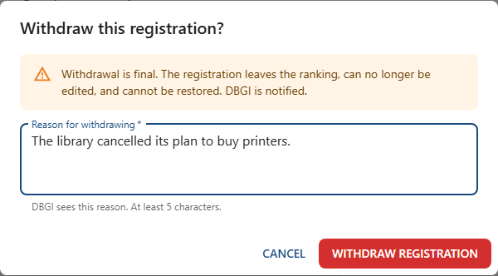
Figure 32. Confirming the withdrawal
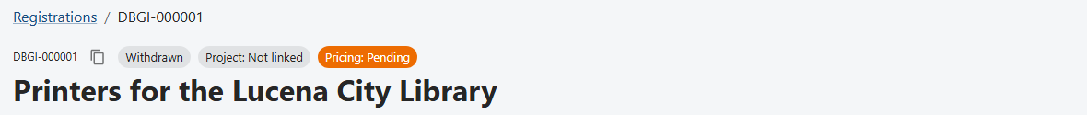
Figure 33. The deal is now Withdrawn
This cannot be undone. The deal leaves the ranking. If the project comes back, register a new deal.

Part 11: Report the result

Report if you won or lost (Partner)
You can do this once DBGI has linked your deal to a project.
- Click Report project outcome.
- Choose Won, Lost, or Cancelled.
- Say what happened, like the notice of award you received.
- Click Send report.
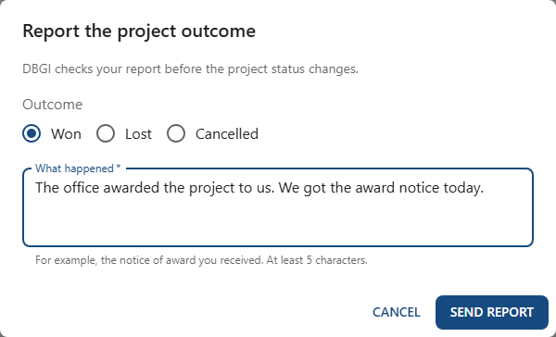
Figure 34. Reporting the result
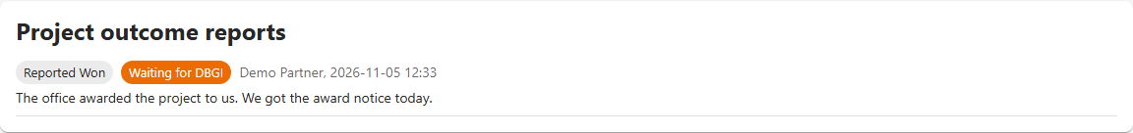
Figure 35. Your report waits for DBGI
If DBGI does not accept your report, you can read the note and report again.

DBGI checks the report (DBGI)
- You get a message and an email.
- Open the deal and find Project outcome reports.
- Click Confirm or Do not accept, and add a note.
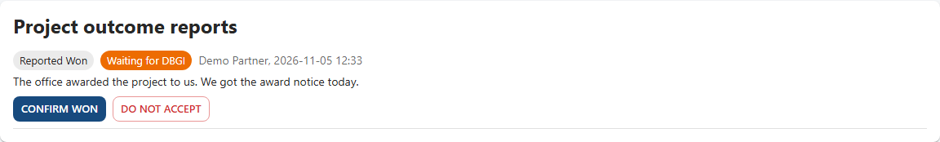
Figure 36. The report waiting for your decision
Confirming changes the project's status for every deal linked to it. The partner gets a message.

Part 12: Time limits

The time limits (Everyone)
What | Limit | What happens
A deal DBGI has not confirmed | 60 days | Reminder on day 53. On day 60 it goes back to DBGI's review list. It is never rejected by itself.
A project on hold | 60 days | Reminder on day 53. On day 60 the deals go back to DBGI for review.
An approved price | 90 days if DBGI sets no date | Reminder 14 days before it ends. After that it shows as Expired.
A renewed price | 30 more days | Added to the end date, or counted from today if the price has ended.
We count every calendar day, in Philippine time. Reminders start once IT turns on the portal's daily job.

Put a project on hold (DBGI)
Use this when a tender is postponed or will be posted again.
- Click Administration, then Opportunities.
- Open the project.
- Set Project status to On hold.
- Click Save.
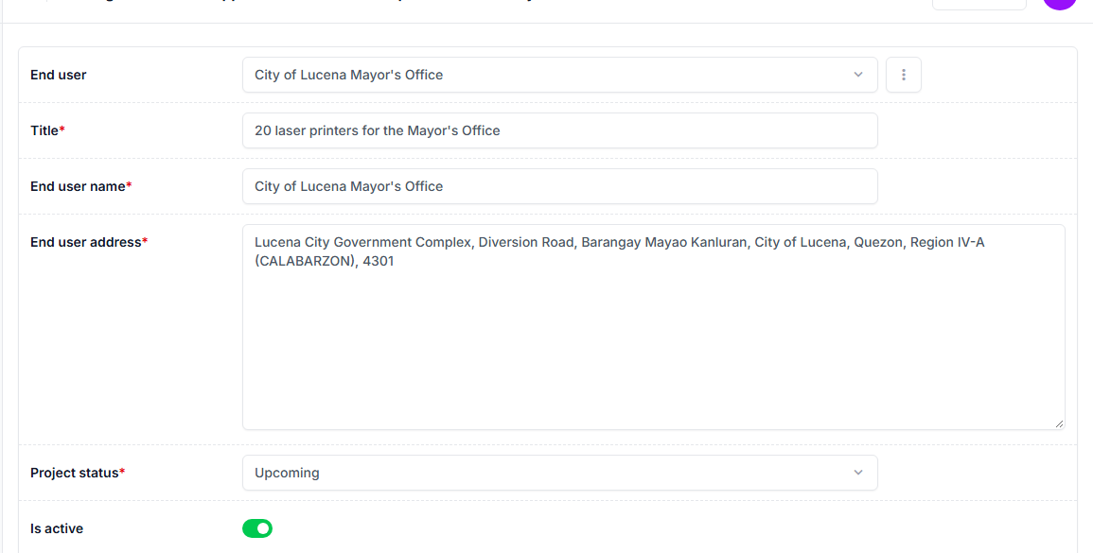
Figure 37. The project form
Deals keep their place for 60 days. Any other status ends the hold. A new hold starts a new 60 days.

Part 13: Other DBGI tasks

Change a list price (DBGI)
- Click Administration, then Products, and open the product.
- Under Product prices, click Add another Product price.
- Type the price, the start date, and the reason.
- Click Save.
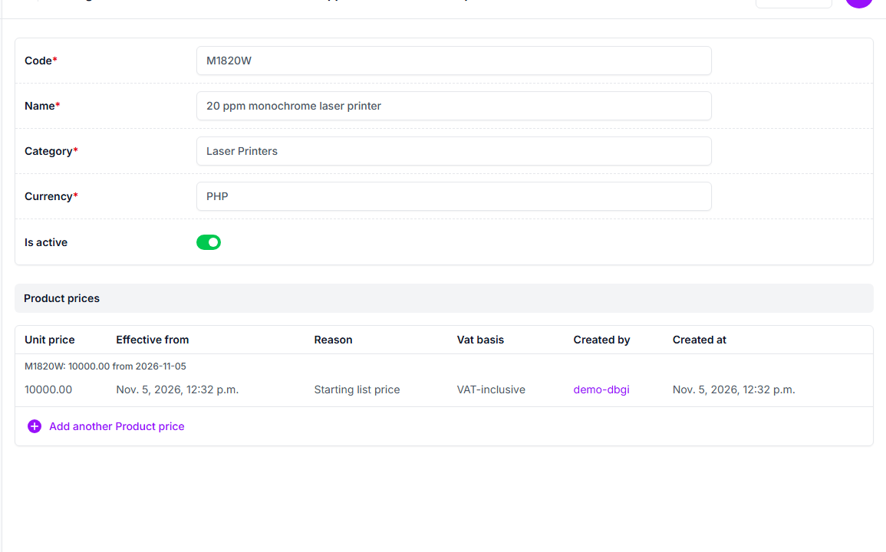
Figure 38. A product and its price history
Old prices are never changed or deleted. A start date in the future schedules the change.

Apply today's prices to a deal (DBGI)
- Open the deal and click Apply current list prices.
- Type your reason.
- Click Apply prices.
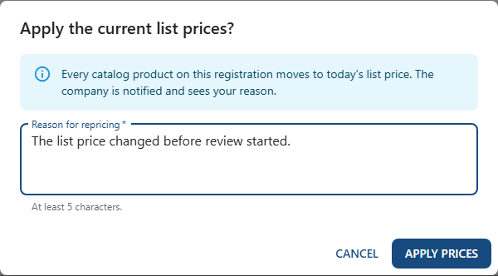
Figure 39. Applying today's list prices
You can do this until price review starts. The partner gets a message and can read your reason.

Add a product to the catalog (DBGI)
A product marked Not in catalog gets no price review until you do this.
- Open the deal and click Add to catalog on the product.
- Choose New product or Existing product.
- Fill in the details and your reason.
- Click Add to catalog.
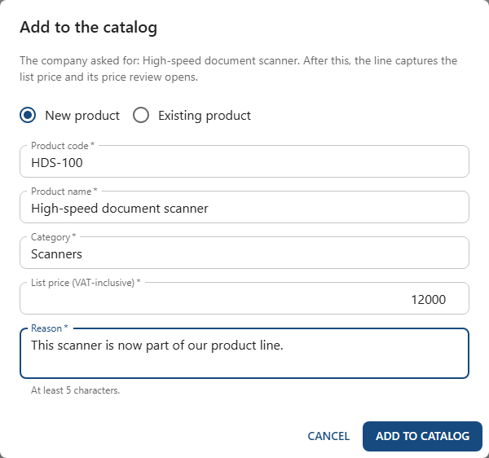
Figure 40. Adding the product
The product now has a list price, and its price review opens. The partner gets a message.

Decide a tie (DBGI)
A tie means two companies registered at the very same time.
- Click Rankings, then Decide tie.
- Use the arrows to put the companies in order.
- Type your reason, then click Save order.
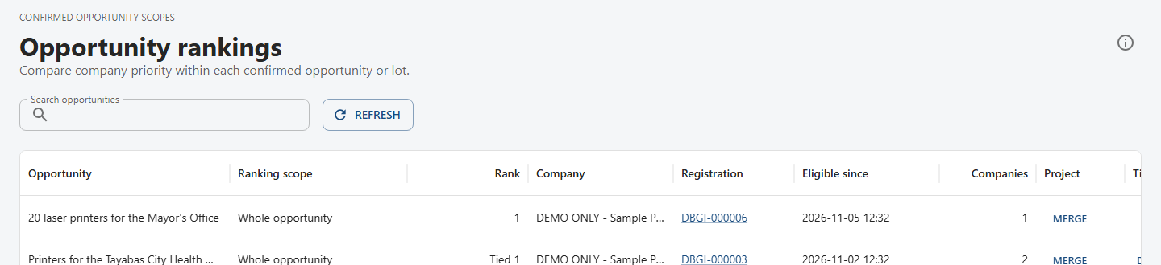
Figure 41. DBGI sees every company
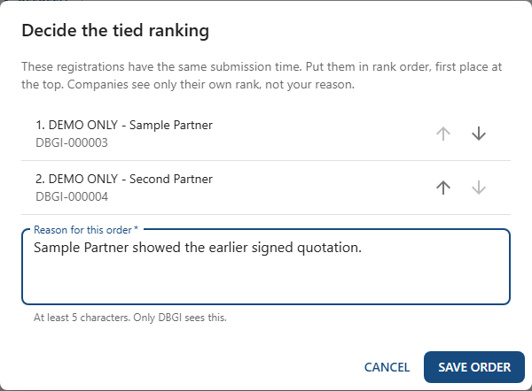
Figure 42. Setting the order
Companies see only their new rank, not your reason.

Merge two projects (DBGI)
Use this when you learn that two projects are the same tender.
- Click Rankings, then Merge on the project to close.
- In Merge into, choose the project to keep.
- Check the new ranking. The earliest deal comes first.
- Choose what happens to decided prices.
- Type your reason, then click Merge projects.
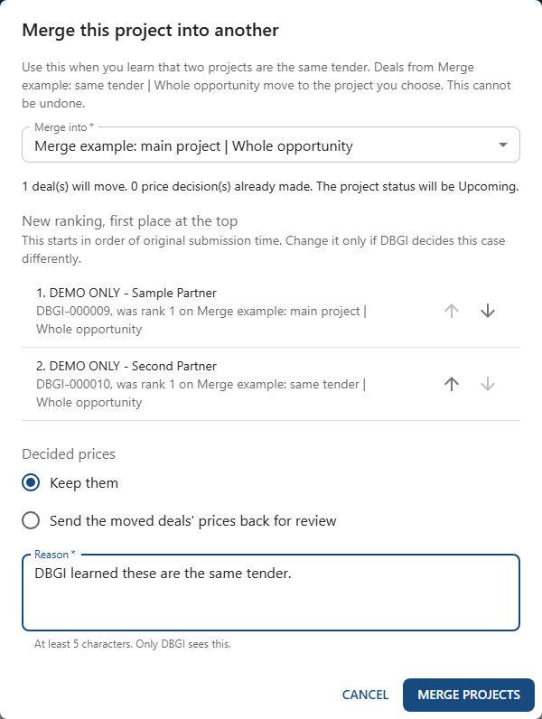
Figure 43. The new ranking before you merge
This cannot be undone. Companies get a message, but only DBGI can read your reason.

Split a deal (DBGI)
Use this when one deal covers separate lots.
- Open the deal and click Split deal.
- Tick the products to move. At least one must stay.
- Type a new lot name, or choose an existing lot.
- Choose what happens to decided prices.
- Type your reason, then click Split deal.
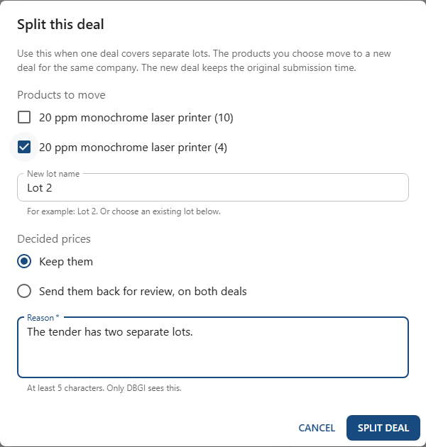
Figure 44. Moving a product to a new lot
The new deal keeps the same company and the original submission time.

Keep the public holiday list (DBGI)
The portal needs this list to count working days.
- Click Administration, then Public holidays.
- Click the add button.
- Type the date and the name of the holiday.
- Click Save.
A working day is Monday to Friday, without public holidays. After 5:00 PM, counting starts on the next working day.

Part 14: Repeat orders

What is a repeat order? (Everyone)
The same buyer orders more of the same item, without a new bidding.
The rule | What it means
Same end-user | The order must come from the same office as the original deal
Notice of Award (NOA) | The buyer's letter saying you won. It must say repeat order.
Notice to Proceed (NTP) | The buyer's letter saying go ahead. It must say repeat order.
A valid approved price | If the price has ended, renew it first
If any of these is missing, DBGI declines it. You can register a new deal instead.

Ask for a repeat order (Partner)
- Open the deal and click Request repeat order.
- Type the quantity for each product.
- Add both letters, the NOA and the NTP.
- Tick the box to confirm what the letters say.
- Click Send request.
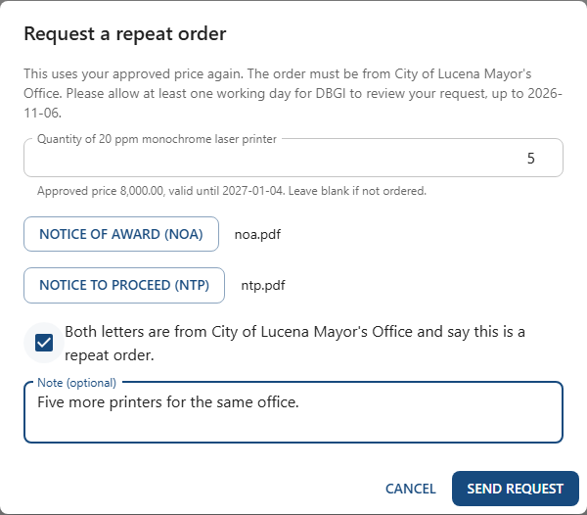
Figure 45. Asking for a repeat order
Please give DBGI at least one working day.

DBGI decides the repeat order (DBGI)
- Open the deal and find Repeat orders.
- Click NOA and NTP to read the letters.
- Click Accept or Decline, then type your reason.
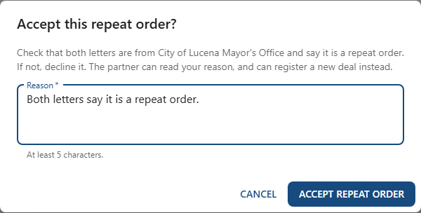
Figure 46. Accepting the repeat order
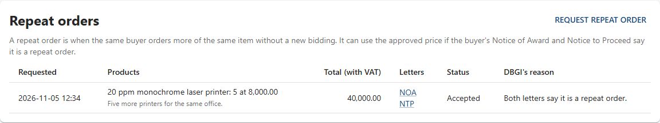
Figure 47. What the partner sees afterward
The partner gets a message and can read your reason.

Part 15: Quick help

Five things to remember
- Register early. The first to register gets rank 1, and rank 1 gets the best price.
- A requested price is not an approved price. Wait for DBGI.
- Read Activity. DBGI's reasons and instructions are there.
- Do not upload private papers or other companies' prices.
- Withdrawing is final. You would need to register a new deal.

I want to…
I want to... | Go to
Add a deal | Deal list, then New registration
Fix or change a deal | Open the deal, then Edit registration
See DBGI's reason | Open the deal, then Activity
See my approved price | Open the deal, then Commercial approvals
Make my price last longer | Commercial approvals, then Request renewal
See my place on a project | Rankings
Use my approved price again | Open the deal, then Request repeat order
Tell DBGI I won or lost | Open the deal, then Report project outcome
Stop a deal | Open the deal, then Withdraw registration

Word list
Word on the screen | What it means
End-user | The government office that will buy
Opportunity | The project that companies are bidding for
Whole opportunity (scope) | The whole project, not just one lot of it
Competitor item | The other brand's product and its price
Attachment | Your proof, like a request for quotation
List price | DBGI's normal price, with VAT
Requested unit price | The price you ask for, for one piece
Approved unit price | The price DBGI agreed to, for one piece
Commercial approvals | DBGI's price decisions
Rationale | The reason for a decision
Renewal | Asking DBGI to make a price last longer
Repeat order | The same buyer orders more, without a new bidding
NOA and NTP | The buyer's letters: Notice of Award, Notice to Proceed

